**GREENWOOD COLLEGE**

**Mathematics Methods Units 3 & 4**

**Test 2 Further Differentiation & Applications 2019**

Name Mark /26

**All electronic devices must be switched off and in bags.**

**Access to Formulae Sheet allowed. No notes.**

**No calculators allowed in this section. Time limit 25 minutes.**

1. [ 2, 2, 1 = 6 marks]

The graph of $y=f(x)$ is shown below, where $f\left(x\right)=e^{x}(x^{2}-3)$.

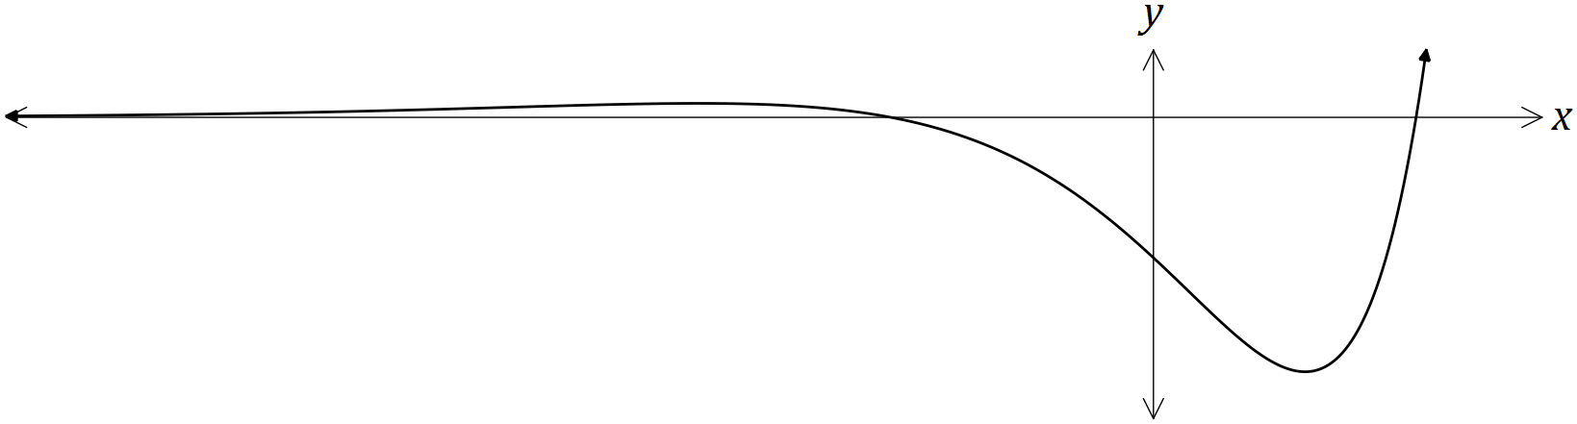

**a)** Determine $f^{'}\left(x\right)$, the equation of the gradient function.

**b)** Determine the co-ordinates of the stationary points of $f(x)$.

**c)** Determine the exact co-ordinates of the X-intercepts of $f(x)$.

**2. [ 3 marks ]**

Evaluate $\lim_{h→0}{{\left(\frac{\tan{π/6 - 1/{\sqrt{3}}}}{h}\right)}^{}}$

**3. [ 5 marks ]**

State the exact gradient of the tangent to the function when

4. [ 3, 2 = 5 marks ]

(a) Determine $\frac{d}{dx}\left(\frac{1+e^{2x}}{1+\sqrt{x}}\right)$. (Do not simplify) (3 marks)

(b) Determine $\frac{d}{dx}$ $\left(2x\sin\left(3x\right)\right)$. (2 marks)

**5. [ 2, 2, 2, 1 = 7 marks ]**

Suppose P and Q are points on the unit circle corresponding to the angles $θ$ and $θ+∆θ$ respectively from the positive *X*-axis

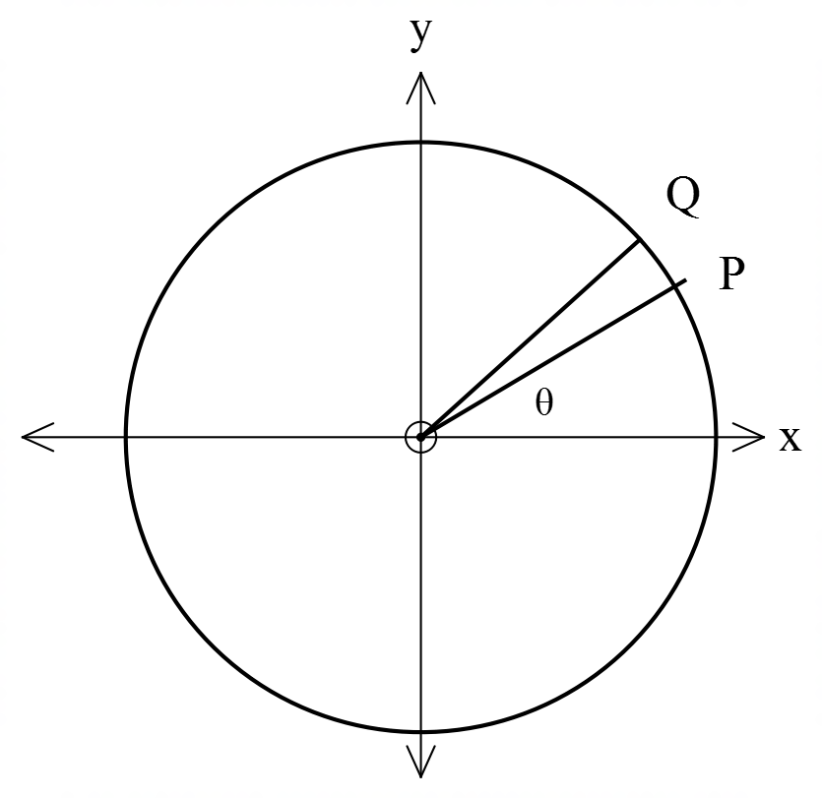

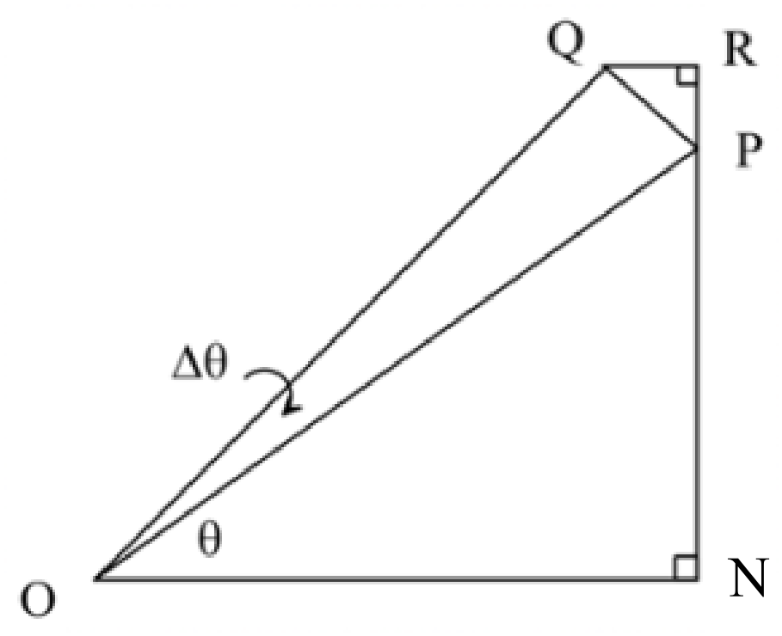

**a)** Explain why PR = $\sin\left(θ+ ∆θ\right)-sinθ$

**b)** Explain why, as Q approaches P, $\hat{QPR} ≈ θ$

**c)** Use right angles trigonometry in $∆QRP$ to show that

$\cos{θ ≈ \frac{\sin\left(θ+ ∆θ\right)-sinθ}{∆θ}}$

**d)** Hence explain why as $∆θ→θ, \cos{θ}= d/{dθ}(\sin{θ)}$

**GREENWOOD COLLEGE**

**Mathematics Methods Units 3 & 4**

**Test 2 Further Differentiation & Applications 2019**

Name Mark /32

**All electronic devices must be switched off and in bags.**

**Access to Formulae Sheet and one sheet of A4 notes allowed. Use of approved calculators is assumed in this section. Time limit 30 minutes.**

**6.** **[ 3, 1, 1 = 5 marks]**

**a)** Use your CAS calculator to determine **exactly**

$\lim_{n→∞}{{\left(1+\frac{1}{kn}\right)}^{n}}$ for $k=1, 2 \& 3$

**b)** Use your results to suggest the exact value of $\lim_{n→∞}{{\left(1+\frac{1}{kn}\right)}^{n}}$,

where $k$ is a positive integer.

**c)** There exists a unique number for which $\lim_{h→0}{{\left(\frac{a^{h}-1}{h}\right)=1 .}^{}}$

State that number.

7. [ 1, 2, 2, 2 = 7 marks ]

The voltage between the plates of a discharging capacitor can be modelled by the function $V\left(t\right)=7e^{kt}$, where $V$ is the voltage in volts, $t$ is the time in seconds and $k$ is a constant.

It was observed that after three minutes the voltage between the plates had decreased to 0.3 volts.

(a) State the initial voltage between the plates. (1 mark)

(b) Determine the value of $k$ to 3 significant figures. (2 marks)

(c) How long did it take for the initial voltage to halve? (2 marks)

(d) At what rate was the voltage decreasing at the instant it reached 4 volts? (2 marks)

**8. [ 10 marks ]**

Use calculus to find the coordinates and nature of stationary point(s) and inflection points for $y= e^{x}\cos{x}$ for $-π≤x≤π$

**9. [ 1, 3, 2, 3 = 10 marks ]**

The water level at a jetty near Ocean Reef on a particular day is modelled by

$h=3+ \cos\left(\frac{πt}{12}\right), 0≤t≤24$,

where $h$ metres is the depth of the water measured from the ocean bed at time $t$ hours after 6 a.m.

**a)** When is low tide?

**b)** Determine the average rate of change of the water depth between 7 a.m. and 10 a.m.

**c)** State the rate of change of the water depth at 10 a.m.

**d)** When is the water level increasing at its greatest rate during the course of that 24 hours ?